SIDG’s Housing Revolving Loan Fund & Qualifications

The Southern Iowa Development Group, Inc. Housing Revolving Loan Fund (SIDG H-RLF) was created to help first-time homebuyers meet the need for a down payment on a home. It has been determined that the lack of sufficient down payment is the major obstacle for individuals when looking to obtain a home loan.

The SIDG Housing Revolving Loan Fund is available to eligible homebuyers in SIDG’s eight county region where local match has been provided. These counties include Adair, Adams, Clarke, Decatur, Madison, Ringgold, Taylor, and Union.

Each loan that SIDG makes requires a 25% local match in funds. The match can be provided by any source such as a bank, development group, realtor, city, county, or private individual.

A first-time homebuyer is defined as someone who has not owned or purchased a home in the last three years. SIDG can generally make a loan to a borrower at any income level. At least 51% of the first-time homebuyers must meet low-to-moderate income guidelines. Due to the large number of low-to-moderate income persons seeking loans in this area, SIDG is able to maintain this percentage.

The SIDG H-RLF program assists first-time homebuyers with down payment assistance.

The local financial institution or realtor will most likely be the buyer’s first contact regarding the SIDG H-RLF program. The financial institution will conduct the initial phase of the loan review and application process and is also required to sign the SIDG loan application form.

H-RLF Regulations &
Financial Obligations

1. SIDG can loan a maximum of $6,500, however, the loan amount must be matched dollar for dollar by funds from the borrower at closing. The match amount must be shown on the closing statement.

Down-payment funds MUST come from the buyer in the form of cash only:
- Does NOT include funds received at closing from the seller.
- Does NOT include funds received at closing for property taxes.
- Does NOT include funds prepaid for property insurance.
- Does NOT include funds prepaid into escrow for future expenses.
- Does NOT include proceeds from a separate loan from another source.

2. The interest rate on SIDG H-RLF loans is a fixed simple interest rate of two percent (2%).

3. The length of the loan is seven years; however, interest and payments are deferred for the first two years. Amortization of the loan will be made in equal monthly installments during the last five years of the loan. Therefore, the borrower will not begin making monthly payments until two years after the loan is closed.

4. An application fee of $100 will be charged to borrowers. This fee helps offset costs of loan packaging, servicing, monitoring, and marketing efforts of the SIDG H-RLF.

5. A closing cost of one (1%) percent of the purchase price of the house is to be paid to SIDG at closing. This amount may be paid by the buyer, seller, realtor, or split between the parties.

6. SIDG will place a second mortgage on the property to secure the loan. Your financial institution will hold the first mortgage.

There is a $500 fee if the borrower later chooses to refinance and wishes to have SIDG subordinate to a new mortgage. SIDG will NOT subordinate if the new loan includes paying off additional debt such as credit cards and other loans or to receive cash.

7. All loans will be monitored to ensure payment schedules are followed. Any misrepresentation of fact or fraudulent activities will not be tolerated and the loan will be subject to recall.

8. The SIDG H-RLF is a separate loan obligation from the loan that the borrowers have with their bank. Arrangements or changes regarding the loan made with the bank do not automatically apply to the SIDG loan.

9. H-RLF borrowers must agree the home
will be their principal place of residence. If they move out or choose to rent or sell the home, the SIDG loan would be due and payable in full upon that event.

Who do I talk to first?
The local financial institution and/or local realtor will most likely be the buyer’s first contact regarding the SICOG H-RLF program. The financial institution may conduct the initial phase of the loan review and application process and is required to sign the SICOG loan application form.
The local realtor may also be the initial contact for the buyer and can supply information regarding the SICOG H-RLF program to the homebuyer.

SICOG Staff

Executive Director, Beth Waddle
Finance Director, Judy Brimm
Regional Planner, Jeremy Rounds
Regional Planner, Terry Niestadt
Transportation Planner, Jessica Hagen
Planning Tech, Kendra Comstock

SICOG Executive Board

Chairperson, Jerry Walker, Adair County
Vice-Chairperson, Diane Fitch, Madison County
Secretary, Karen Zabel, Taylor County

Treasurer, Scott Akin, Adams County
Randy Dunbar, Clarke County
Dan Christensen, Decatur County
Colby Holmes, Ringgold County
Rick Friday, Union County
Doug Davidson, Private Sector Representative
Tom Leners, Private Sector Representative
Raelynne Risser, Private Sector Representative
Jodie Geist, Private Sector Representative
Wayne Pantini, Member-At-Large

SIDG

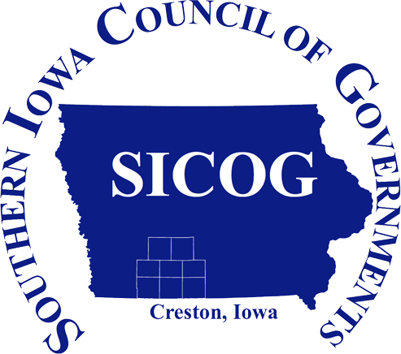

Housing Revolving Loan Fund

Southern Iowa Council of Governments
101 East Montgomery Street
Creston, IA 50801-2406

Phone: 641-782-8491
Fax: 641-782-8492
Website: www.sicog.com
Facebook: www.facebook.com/sicog

