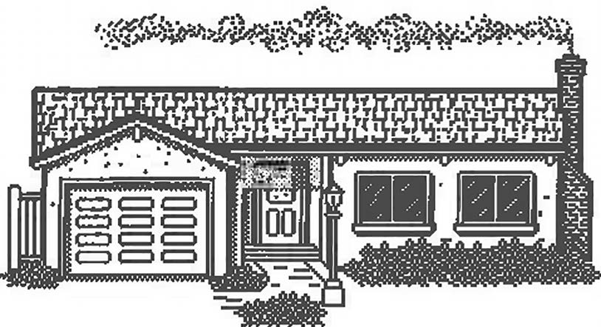
Southern Iowa Development Group, Inc.
101 East Montgomery St. Creston, Iowa 50801
Ph. (641) 782-8491 Fax (641) 782-8492

First-Time Home Buyer Housing Revolving Loan Inquiry

Applicant Phone SSN Address (current) City State Zip Email
Applicant
Employer Phone
Address City State Zip Co-Applicant Phone SSN Address (current) City State Zip Email
Co-Applicant
Employer Phone
Address City State Zip

Combined Annual Income $ Number in Household
I have not owned a home before I have not owned a home in the last 3 years
Address of Last Home owned
DOWNPAYMENT ASSISTANCE (maximum $6,500):
Amount Requested $ Amount of downpayment by Applicant:

Purchase Price of Home $
Proposed Purchase Home Address City State Zip Realtor Name Phone Email
Address City State Zip

Name of Loan Officer: Phone
Local Lending Institution Email:
Address City State Zip

