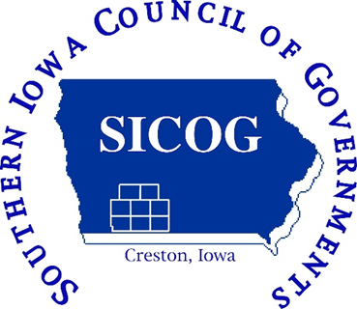

SICOG Staff

Beth Waddle: Executive Director
director@sicog.com

Judy Brimm: Finance Director
brimm@sicog.com

Jeremy Rounds: Regional Planner
rounds@sicog.com

Terry Niestadt: Regional Planner
niestadt@sicog.com

Jessica Hagen: Transportation Planner
hagen@sicog.com
30 IDEAS
IN
30 MINUTES

Kendra Comstock: Planning Technician
comstock@sicog.com

Southern Iowa Council of Governments
101 East Montgomery Street
Creston, IA 50801-2406

Phone: 641-782-8491
Fax: 641-782-8492
Email: sicog@sicog.com
Website: www.sicog.com
Facebook: www.facebook.com/sicog
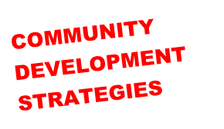

Southern Iowa Council of Governments

- The Local Economic Development group could create a business plan for a business that’s never in the community, and market it to bring a new business to the community.
- Create window displays on vacant buildings to convince or persuade people to put a business in that building.
- Host a zoom room for business roundtables. One or two times a month, where entrepreneurs can drop in, and discuss a particular topic for each meeting.
- Pop up stores, and perhaps connect regionally for a “round robin”.
- Create venture capital, equity investment program.
- Increase long term, school/economic development/chamber/entrepreneur collaboration.
- Expand Co-Working Space. Can be done in: Libraries, School rooms, etc.
- Create a survey to see if there is a need for more co-working space.
- Create an inventory of available remote work jobs. Promote these jobs online.

- Cross market co-workspaces in region.
- Team up with internet providers on costs and infrastructure, giving them naming rights for location.
- Improve overall access and quality of broadband.
- Create a remote work job fair or Zoom fair.
- Use school alumni newsletters to provide job information or a list of remote work in the community.
- Create a “How to” resource for mentorship/apprenticeship programs.
- Create a “How to” hire/education package for businesses to hire high school graduates.
- Create info packets based on local jobs for guidance counselor offices.
- Create short, with current employees’, videos that explain the jobs, benefits, and lifestyle it provides for them.
- Compare on charts/videos, the cost of living where they grew up to the cost of living where they want to live.

- Career fairs. Work with community, college, and locals to host.
- Host summer job fairs.
- Develop housing incentive for young families, or young adults who are right out of high school.
- Survey or ask young adults what additional amenities would make them stay in the community.
- Develop Housing modernization program.
- Focus on the top two demographics who need housing.
- Support Accessory Dwelling Units (Sometimes called “granny pads” and can be portable.)
- Establish a stormwater utility, using it to fund stormwater projects and to match grants.
- Help locals understand the value younger people put on walkability. (Trails/Sidewalks/Streets.)
- Create a downtown assessment/plan with a vision of what each block will look like in twenty years.
- Survey the community/region for a trails plan.

