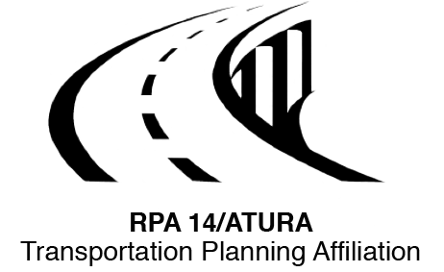 Region 14
Serving the Counties of…

ADAIR - TAYLOR - UNION - RINGGOLD - ADAMS

Chair: Colby Holmes, Ringgold County Vice-Chair/Secretary: Ron Fitzgerald, Taylor County

RPA-14 / ATURA POLICY BOARD

Date/Time: Tuesday November 8, 2022 immediately following Technical Committee Meeting @ 1:00 pm

Place: Olive Branch Restaurant, 108 E Iowa Street, Greenfield, Iowa 50849
AGENDA
- Call to Order
- Roll Call
- Additions to Agenda (Discussion or Informational Items Only)
- Approval of July 12, 2022 & September 20, 2022 Minutes of the RPA-14/ATURA Policy Board Meetings
- Action Items
  - No Action Items
- Discussion or Informational Items
  - Iowa DOT – Scott Suhr
  - Technical Committee
  - SICOG
  - Other from the public
- Set Date of Future Meeting and Host County (Tuesday, February 14, 2022 in Taylor County)
- Adjournment

