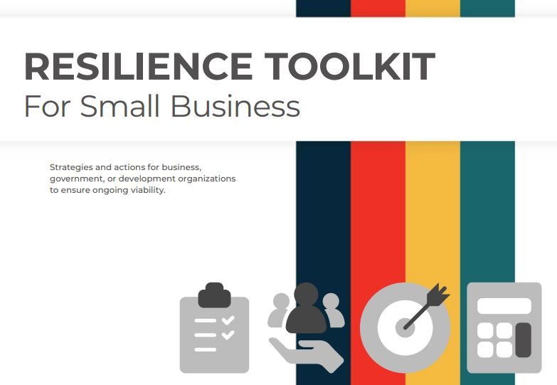
SICOG Resiliency Toolkit Released to Assist Business, Government and Development Organizations with Ongoing Viability
Disaster preparedness is nothing new to governments, businesses, and development organizations. The well-laid plans to be used in case of fire, flood, or storm are commonplace. They help to provide a blueprint for action at a moment of crisis when an existing strategy can be a thing of comfort for those dealing with the unthinkable. Of course, the types of disastrous situations have expanded — from terrorism to cyber attack to, now, ongoing Covid pandemic.
Resilience planning, though, is another matter. It recognizes that disasters and difficulties will happen, that immediate response is necessary, but that long-term implications will require a different set of strategies and actions to ensure ongoing viability, whether for a business, a government, or a development organization.
SICOG recently released a workbook that is intended to serve as a toolkit for resiliency planning— with resources and references for traditional partners. The toolkit, however, is not all-inclusive. There will be partners in your community or your region who may need to be included or engaged. That’s part of the planning process — identifying those entities that need to be at the table, both now and at times of crisis. The toolkit is also aligned in such a way that you can go directly to key areas of interest, from money to management to marketing. It can also be taken as a whole — a blueprint for action.

Resiliency Resources

Resiliency Toolkit
This workbook is intended to serve as a toolkit — with resources and references for traditional partners. The toolkit, however, is not all-inclusive. There will be partners in your community or your region who may need to be included or engaged. That’s part of the planning process — identifying those entities that need to be at the table, both now and at times of crisis.
The toolkit is also aligned in such a way that you can go directly to key areas of interest, from money to management to marketing. It can also be taken as a whole — a blueprint for action.
SICOG Resiliency Toolkit
https://www.iowaresilience.com/sicog

